Hi, I’m Benjamin Towe author of…………………..and I’m your host for this stop in the Hunt.

If you would like to find out more about the Hunt, please click here - http://vfcscavengerhunt.weebly.com/
Somewhere on this page is a hidden number. Collect all the numbers from all the authors’ posts, and then add them up. Once you’ve added all the numbers, and if I am your last author, please head to the official website and click on the ENTER HERE page to find the entry form. Only entries will the correct number will qualify to win.

The author I’m pleased to be hosting for Virtual FantasyCon’s Blog Hop Hunt today is Steve Moynier, author of The Culhanian Institute of Magic and Technology.

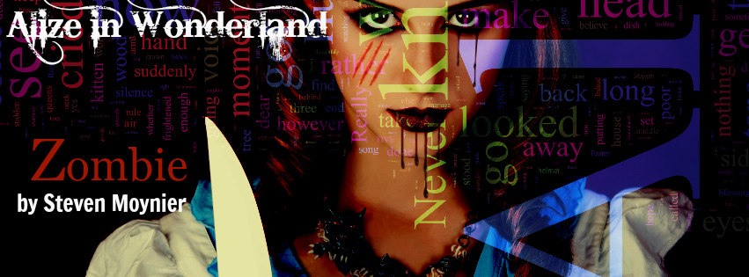

Where are you?

Hello! I know that you lot are wondering: What the heck is going on with Steve? Where is he? What is he doing? Aren't you? Ah, that's because I have the best readers. Worrying about me, I'm exceedingly touched. Okay, Erin might say I'm touched in the head, but touched is touched! I've been a wee bit busy living life, which is hilarious in its way. I've also been writing. I should be writing here more, though, and maybe I'll just have to make it up to you. I now declare this the month of excessive blogging! Not that I expect to beat my earlier combined blogs, but I have plenty of time to do so. Twenty three total since December and I want to say the first two or three months were the big ones! Well then, let's get to it.

As you all know, I have this habit of writing a little. It's not that I can't type fast (because I can), nor that I don't know what to write, I have an idea... I just hadn't been as active about it as I could have. Well, that's changed. I've got a double short story almost ready to go up, and I'm working on some other stuff. Like 36 other short stories. Okay, maybe not quite that many, but quite a hop! I'll tell you a little about each, just a general idea. Are you as excited as I am? I knew it!

So you already know about my short story in that zombie anthology, Once Upon A Zombie tale where I pitted "Alize" against her old antagonists, the people of Wonderland. To be fair, there was little violence. I gave her a gun and barely let her use it. She's tough. Well, that's not my only fantasy-thriller. Another notion I have, one I've been toying with again in recent times, is a mirror version of Earth where all the dark creatures of our imagination hold power. Not only do they live, they rule, and all humanity can do is survive... sometimes. Sometimes we die. It's one heck of a place and it makes even me wonder: Is that what happens to some of our missing people? Who knows?
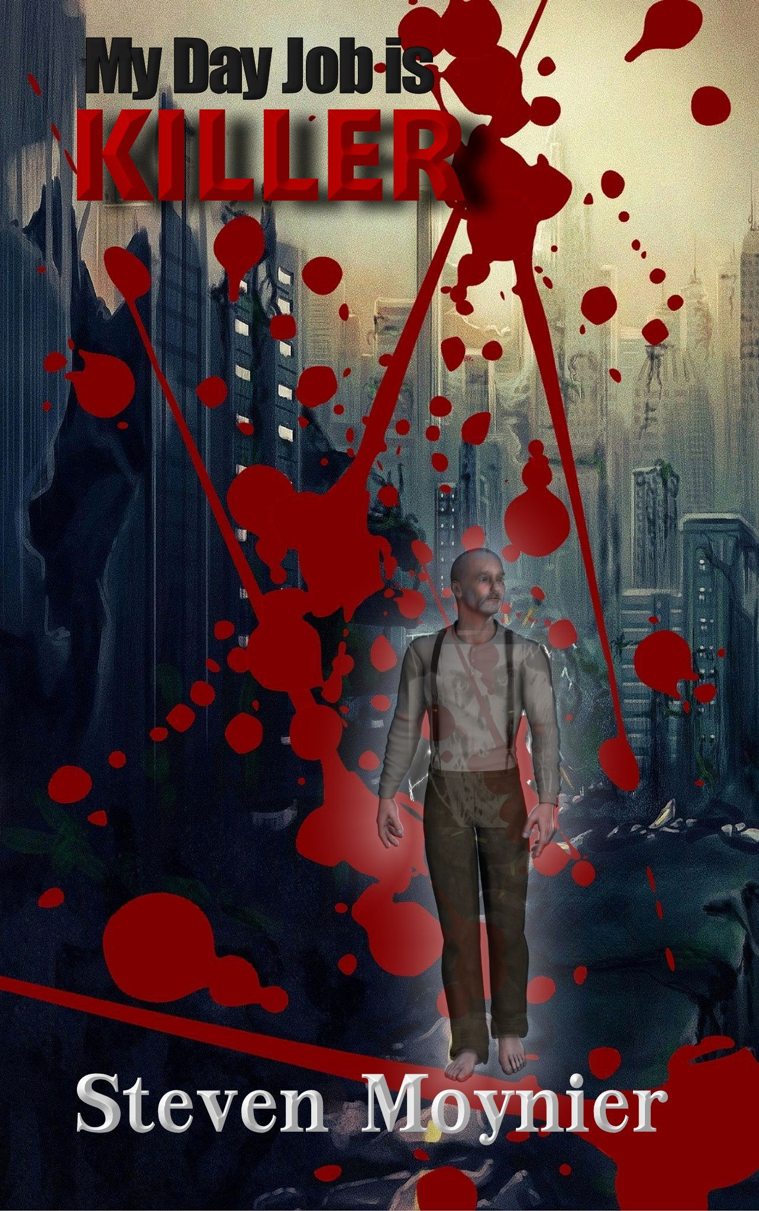
Then there's my Institute set. The Culhanian Institute of Magic and Technology. It's the modern day, magic is real, the supernatural exists, and magically animated corpses are assaulting the Institute! The only problem is, our hero is already dead. Still, for a ghost, he tells a lively story. This one is going up in the next few weeks, or it will as soon as I finish with editing. Then there's a dystopian Terra, a thousand years or so in the future. Humanity was all but destroyed by a weaponized virus and our young hero, a woman named Erin, is on a hunt to discover the history of her world. She takes us all along for the ride, though, which is awfully nice of her!

And then there's Captain Gabrial Scott, a young ship's captain who is forced to turn pirate. He doesn't have the temperament for it, alas, and becomes more of an anti-pirate. His enemy, Admiral Bruce Allen, is hunting him across the galaxy, and the pirate Christopher Alexander is just as determined to see young Captain Scott dead. It's a tough galaxy, and aside from a few loyal friends he is alone in the universe. I'm excited to see how he survives!

Did you find the number? If you did, then click Steve Moynier’s link – eandyil.blogspot.com to continue Virtual FantasyCon’s Blog Hop Hunt.

